

UI/UX DESIGN REPORT

BSC Software Engineering

WAT 1143C

**BSE 21B FT 3**

**Assigned by:** Mr Loovesh Ramwodin

**Done by:**

Keshini Sesungkur 2110_22847

Keerty Sooumbur 2110_22852

Lovena Ujoodha 2110_22856

Ishwari Veeraragoo 2110_22858

**Table of Contents**

Summary 3

Introduction 3

The evolution of ZARA as an online retail store 4

Gantt chart 9

Market Research 10

Methodology 13

Participation recruitment 13

Chart of ZARA site ratings 14

Emotional interpretation 15

Usability Issues 15

Hypothesis 22

Conclusion 23

# **Summary**

This report consists of an introduction of the ZARA online international website along with its evolution from a retail store to an online business website during the past few years.

Moreover, a Gantt chart is presented showing the time taken to complete each step. Then before going onto usability testing our team did market research to identify the problem users might get while using the website in terms of UI and UX components. Thus, after choosing our methodology we recruited the participants required for the quantitative research.

When acquiring all the data, we analyzed the data and list the usability issues that the seven participants had encounter. Afterwards, we provided a hypothesis containing the solutions to improve the ZARA website design according to the users’ preference. At the end we sum up everything in a conclusion.

# 

# **Introduction**

ZARA a retail store that sells clothing and accessories for men, women and kids began its journey in the early 1975 when Amancio Ortega first established a dress making factory under the name of INDITEX. After ten years of having great and unexpected success Ortega concluded opening a small stored named ZORBA which he eventually renamed to the very popular ZARA some years later. The fashion store acted as a pioneer in fast fashion based upon a highly responsive supply chain. ZARA expanded swiftly across the whole globe, and it now operates in about 88 countries and over 22,000 stores. We can also assume that nowadays there are hardly any developed or developing country without a ZARA store. Moreover, ZARA took inspiration from some luxurious designer brands such as GUCCI, but however its strategy is to offer a cutting-edge fashion at a more affordable price.

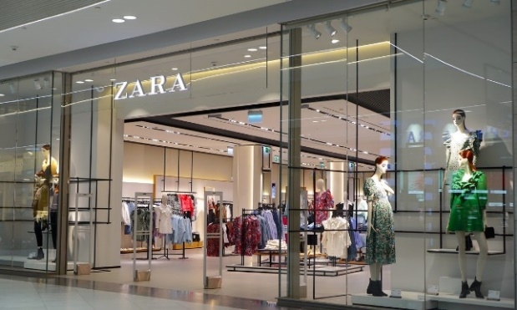 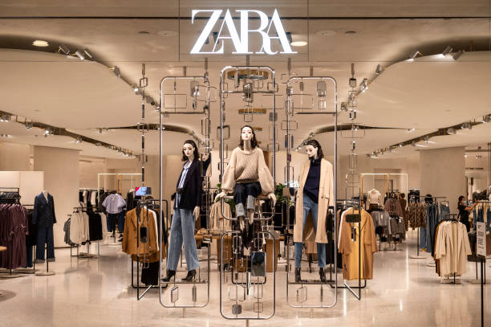

ZARA is highly responsive to trends and that is one of the reasons it is considered to be some of the big celebrities’ favorites.

  

**Kate Middleton** **Gigi Hadid** **Kendall Jenner**

Wearing ZARA Wearing ZARA Wearing ZARA

Blazer. Sweatshirt. Pants.

# 

# **The evolution of ZARA as an online retail store**

It is generally agreed that the innovation and evolution of technology has revolutionized the entire world with its “magic”. After that technology has made a remarkable presence, many stores decided to invest on a digital strategy marketing, in other words, the creation of an e-commerce website. That being said, ZARA launched its very first website on the 2nd of September 2010 and were accessible to countries such as the UK, France, Spain, and Italy. It has later extended its service to many more countries. ZARA really gained its income through the “brick-and-mortar” which refers to as a traditional business that offers products and services to its customers face-to-face, however because of the covid-19 virus the rate of sales dropped to 44% hence INDITEX, the top profitable clothing company, also known as ZARA’s parent company, had to close around 1200 store across the globe and invest more on online retailing.

Below is a graphical representation of the chain stores closure in the United Kingdom:

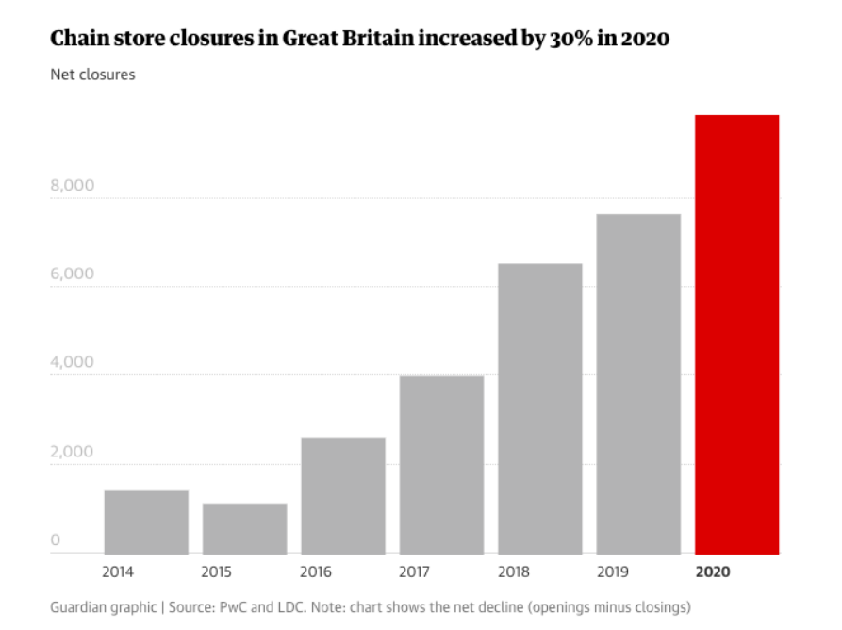

The pandemic had a brutal impact on thousands of retail stores but thanks to the technology, they could recover from their loss through the option of online shopping.

The Zara website offers functionalities such as: allows the user to search, add products to cart, view products and complete a transaction just like any other online shopping websites.

Below is a picture of the website’s home page:

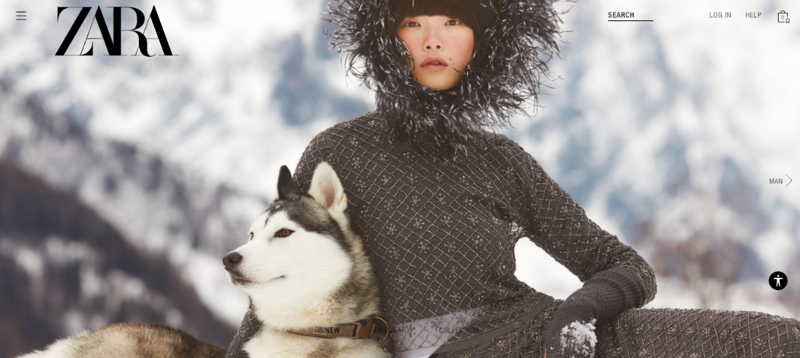

As you can see ZARA’s homepage depicts the brand’s personality. Meaning that it gives almost the same experience as one would get when visiting its physical store.

The website also provides facilities such as the online customer service (for shipping and order status, payment, gift card, gift options and many more). Furthermore, unlike any other websites ZARA has some features integrated for those who are physically impaired as well. This is a very good initiative put in place by the fashion company as very often these people are neglected.

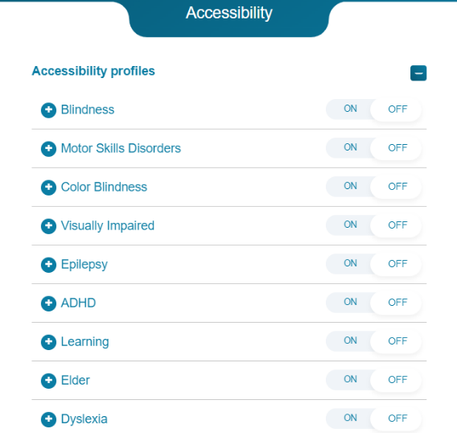 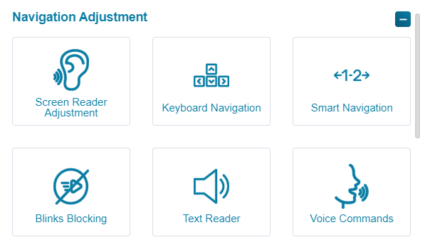

Below is some additional information about the website:

* Over the last three months ZARA.com ranking officially increased from 276th to 194th

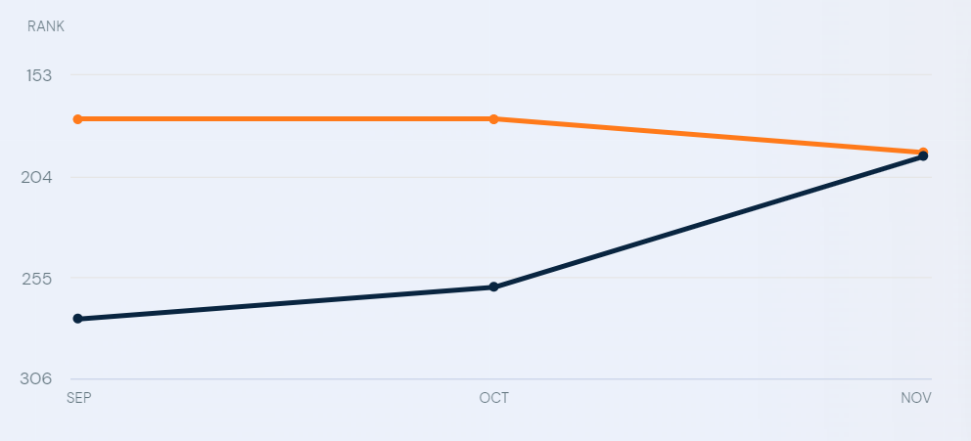

* ZARA’s marketing channel distribution

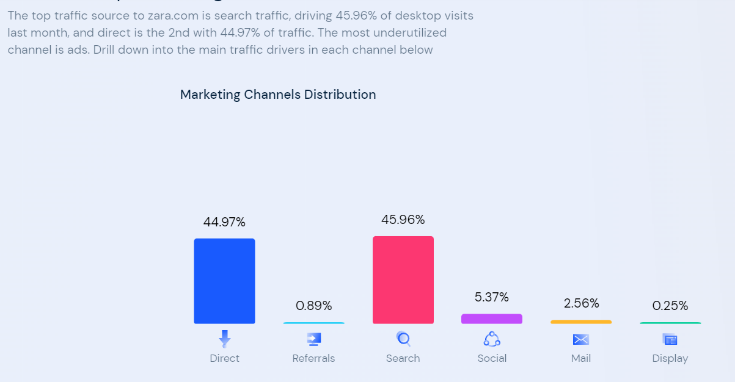

* ZARA’s social network distribution

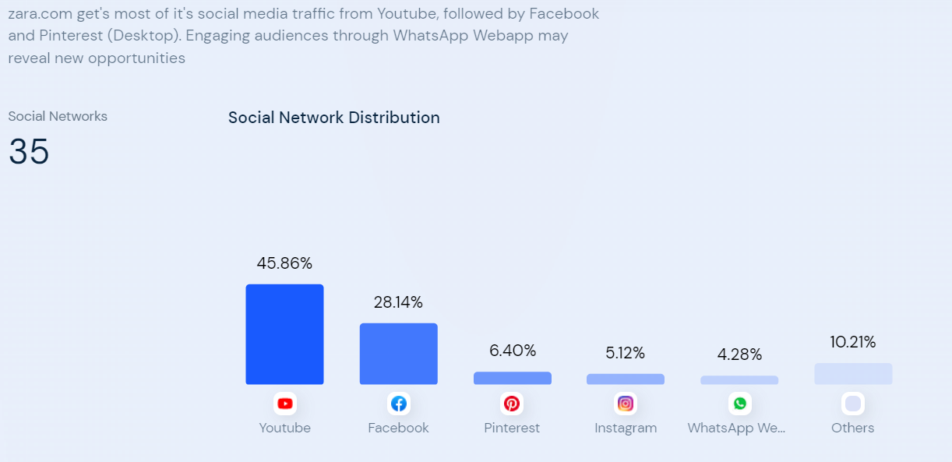

* ZARA’s demographic audiences (gender-wise)

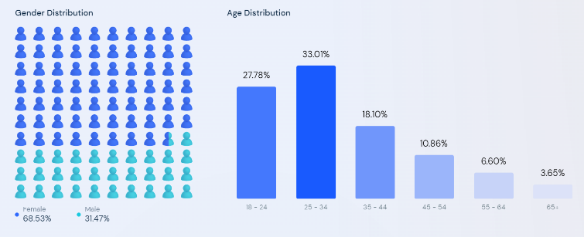

# **Gantt chart**

The Gantt chart below shows a project-specific Gantt chart that describes our planning and track our work progress. It contains the timelines and deadlines of all tasks along with relationships and dependencies between the various activities taken place. It allowed us to simplify our project on ZARA website, improve our visibility and keep everyone on track.

# **Market Research**

Before going to usability test, our team conducted a heuristic evaluation of the ZARA website to identify usability issues. We mainly focused on the design, features, UI parts and other elements that a user will use while searching items for or adding items to cart.

Logo is too large, which might be overwhelming for users.

Search bar too small for an e-commerce website.

Button containing actual item that users want to go through but is barely visible.



Navigation bar hidden behind the hamburger menu; user have to look around for that menu. There’s no easy access.

Poor color contrast, navigation is not visible and if the user clicks on knitwear/collection the slide picture changes. It does not direct the user to the specific page.

Accessibility control for people with disabilities so that they can easily find items.

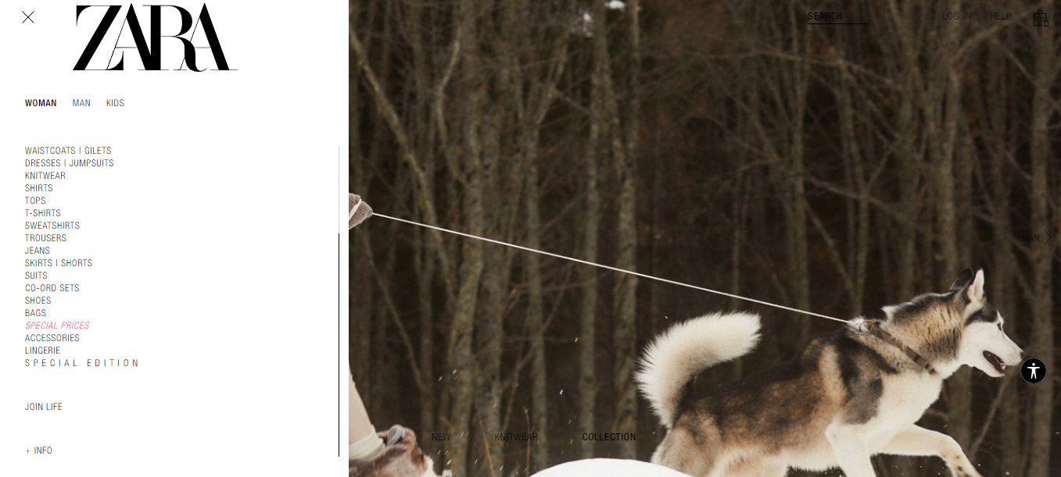

Item list is not categorized. Everything is clumped together and there is spacing issue because the words are capitalized.

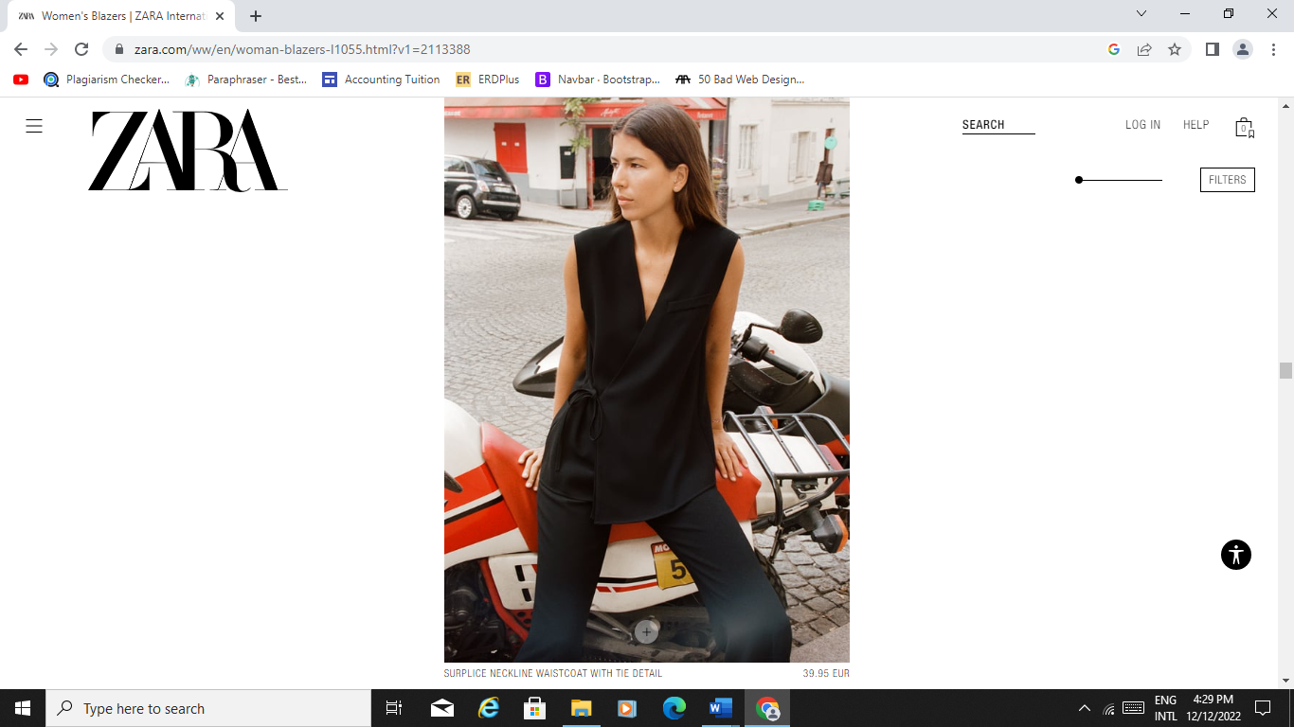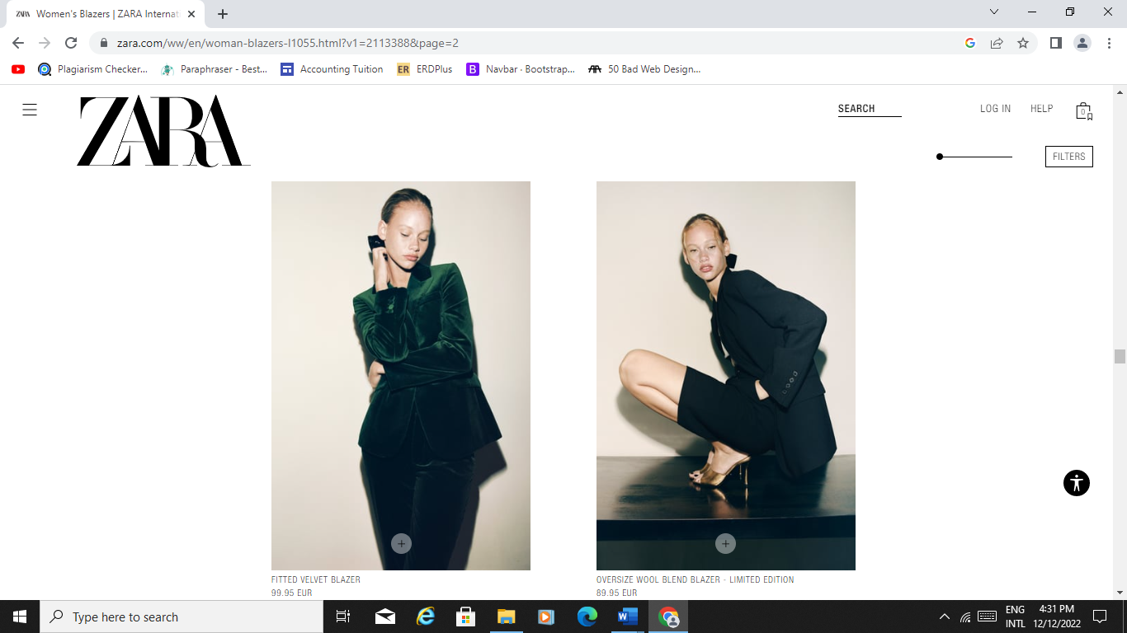

Ability to directly add item to cart.

No clear indication of what this does. If a user plays around then they will know that this can be used to display more than 1 or 2 items.

It seems more like an ad or promo. No precision of item, instead they focus on the model pose. Users have seen the description to know which the actual item is selling.

It’s more like a fashion catalogue rather than an e-commerce website. No define layout, it is just a mix of grid pattern, width, and column size. After at least 5 scroll the user get to see 10 items.

Large image and small text which is not that visible because of the color being used.

Navigation is difficult to read when there an image behind it.

Not able to see item properly because of overlapping.

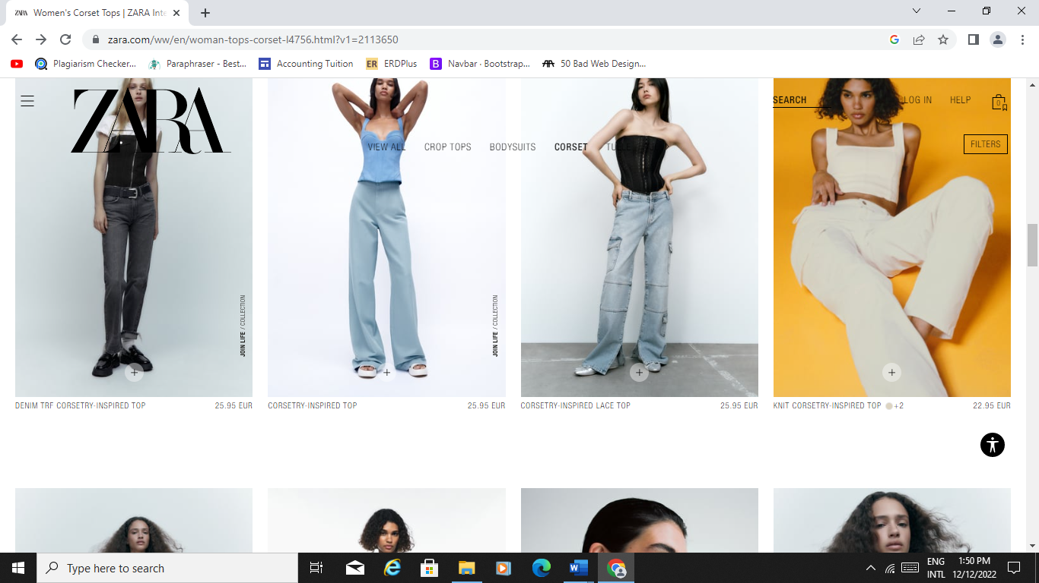

User will be able to find product easily according to their preference of color, price etc.

Infinite scrolling, if a user liked something on the top the user will have to scroll all the way up to look for that item.

It takes control of the scroll.

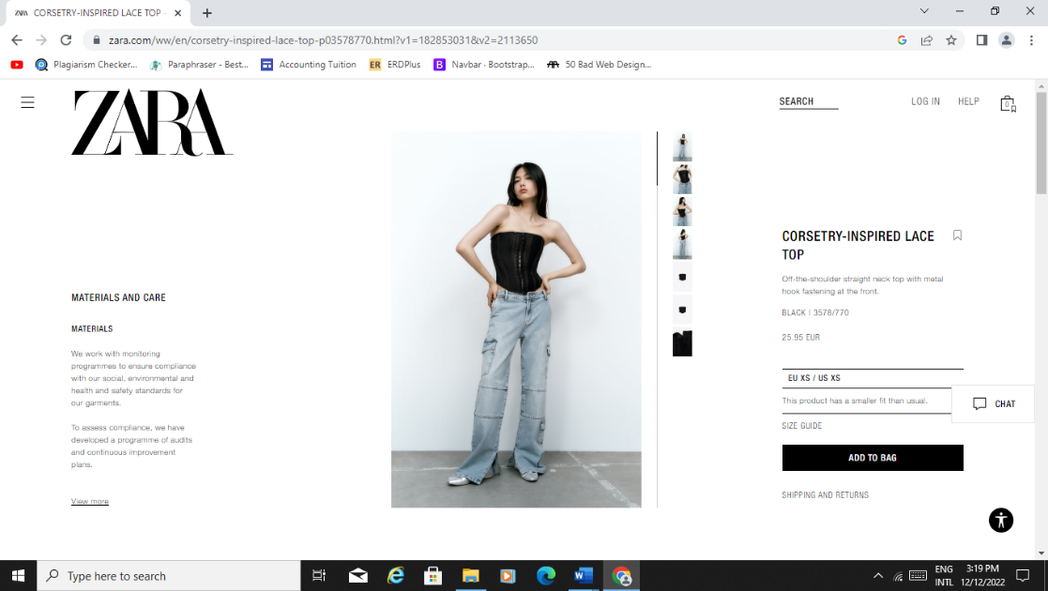

When you click on a size the other sizes are hidden.

Difficult to find the color as it is found in the description section.

Too much of white space and content written very difficult to read due to the color contrast and font size.

Easy access to cart and show how much item the cart contain.

User can easily find items to match it with the clothes they chose.

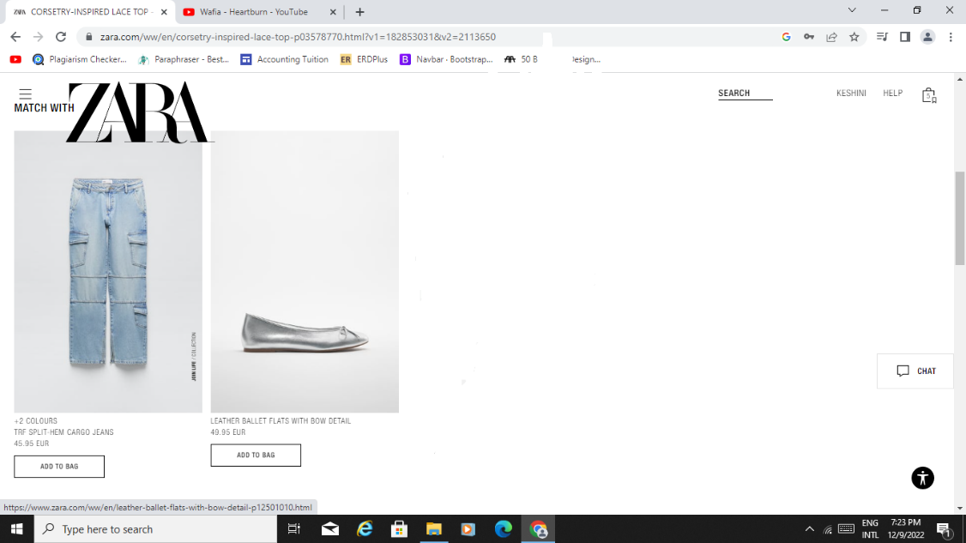

Customer service available for any help user need on the page.

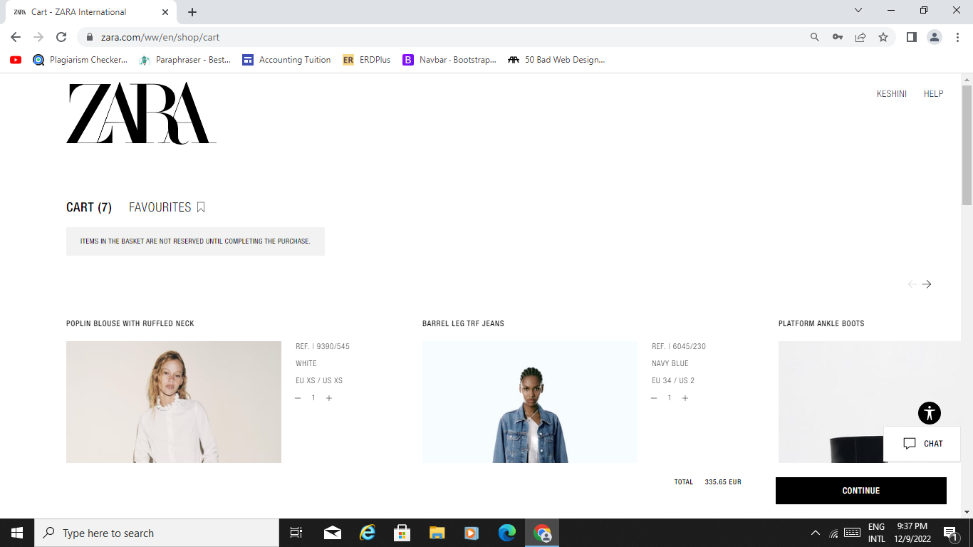

Useful feedback for new users.

If a user is viewing the latest item, he/she has add to cart they will have to scroll horizontally which is not clearly specified, to be able to find the recent item.

Total is the most important element a user’s want to see and is not even noticeable.

# **Methodology**

For the usability testing, our team chose quantitative method to conduct a survey with users who frequently use ZARA website for shopping. First, to find users who shop on the ZARA website we made use of the social media platform and recruited a few participants. We took the participants information and created our questionnaire using google forms. Then we sent each participant the following link:

<https://forms.gle/eHU3vNp4gKfoJNhJ>

This survey will help us understand the user behavior, needs, and find out what is their opinions regarding ZARA website such as: how much they like the website design, what emotion do they feel while using it, what features do they appreciate or what problem have they encountered with the website as well as the changes they want of the ZARA site.

In general, the quantitative data that we obtained from the usability test depicts a poor usability of ZARA website. Some key factors users mention is bad layout design, time consuming to find a product and poor contrast. Mostly, users mention its rather confusing than helpful shopping on the site.

# **Participation recruitment**

Our team recruited 7 users of ZARA website to give their opinions about the benefits and difficulties they had faced while using the website. Before recruiting the participant, we sent an informative questionnaire to them to have a better perspective on their shopping habits and to find out whether they would be appropriate for the usability testing. Most of the users age were between 18 to 24 and others 45 to 54 with six females and one male participant. The participants are not only from Mauritius but from different parts of the world as well.

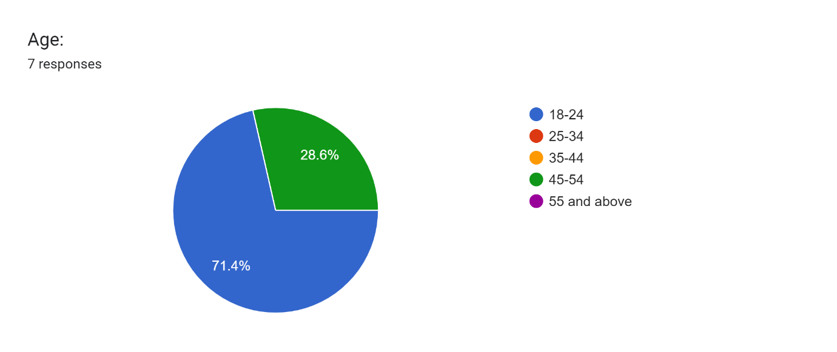

# **Chart of ZARA site ratings**

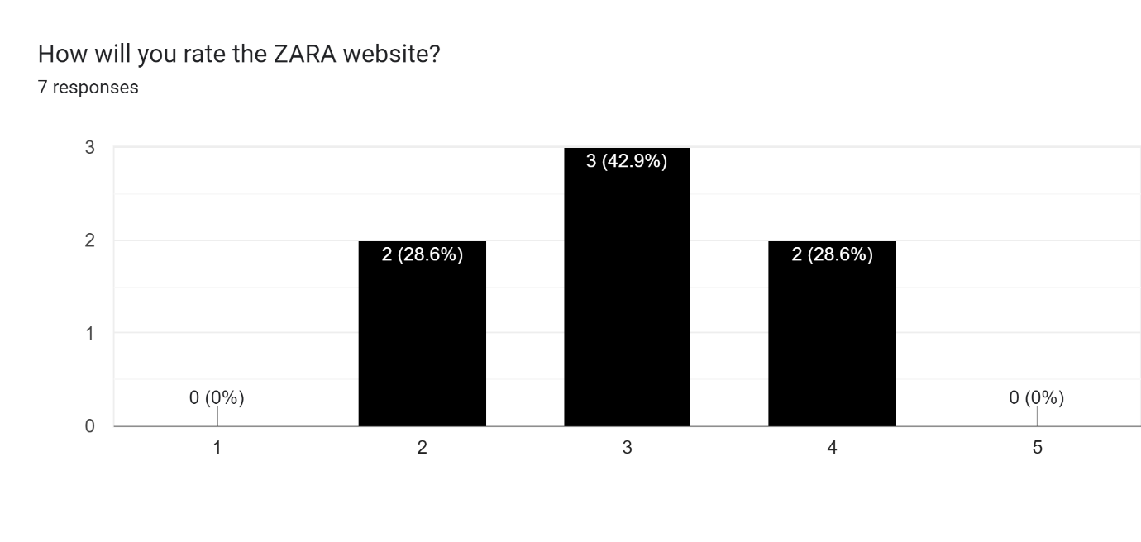

# **Emotional interpretation**

# **Usability Issues**

Moreover, the information that we collected from the survey regarding the usability issues that ZARA users had are as follows:

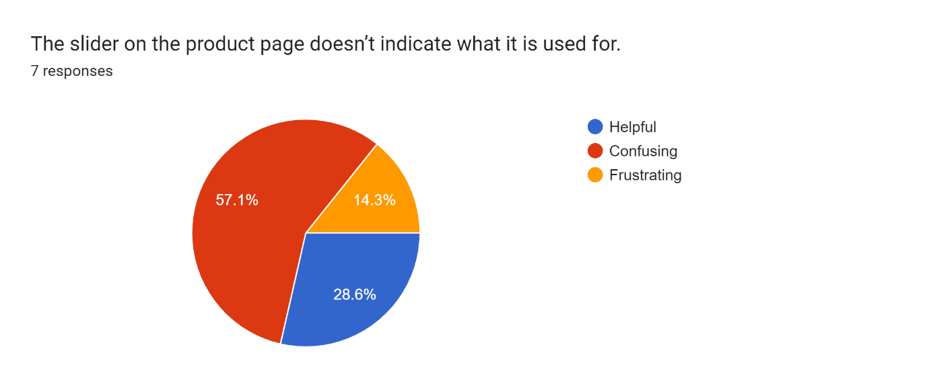

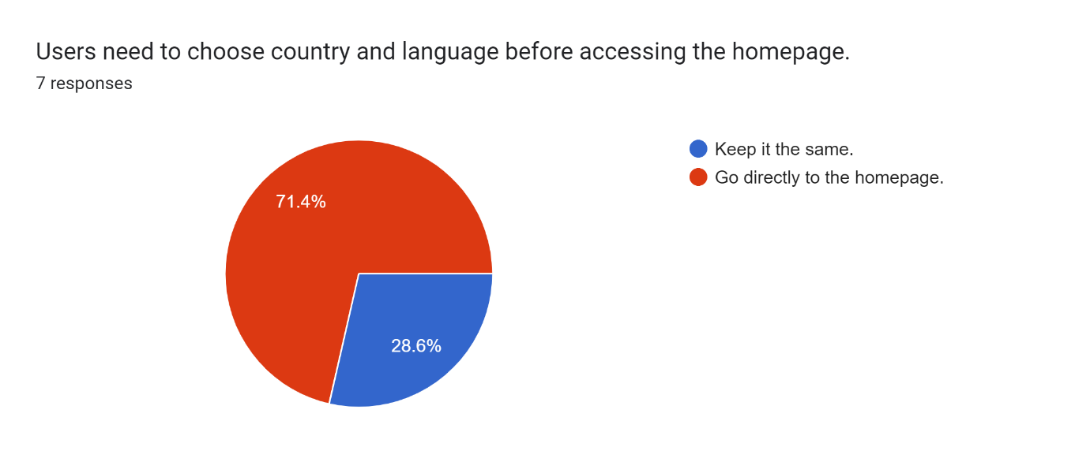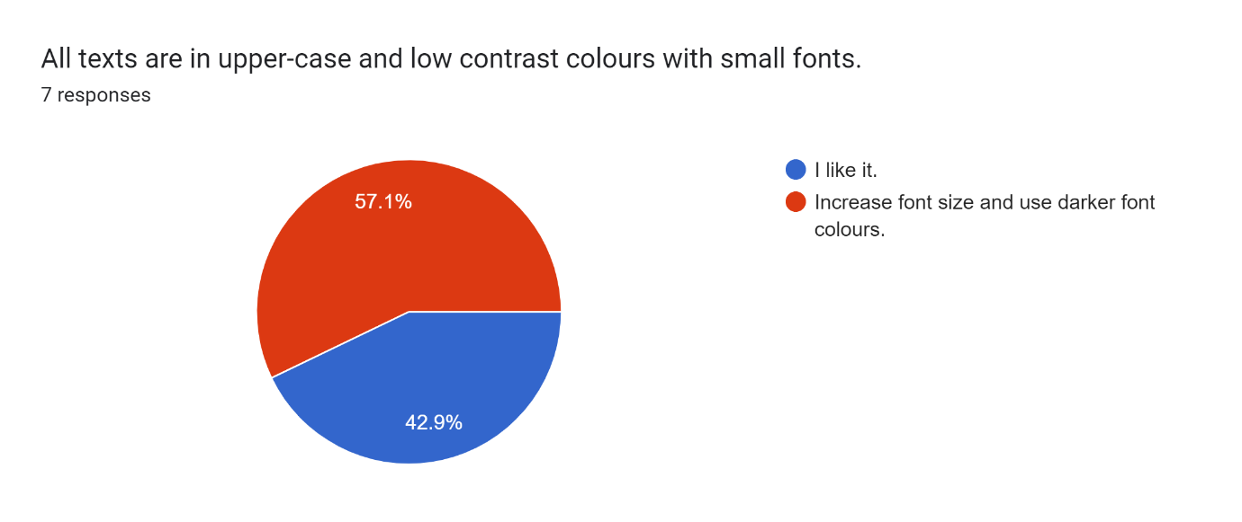

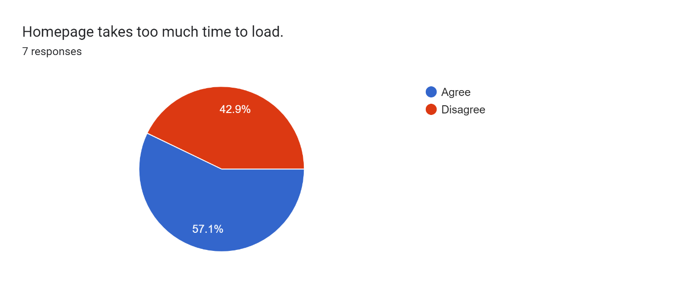 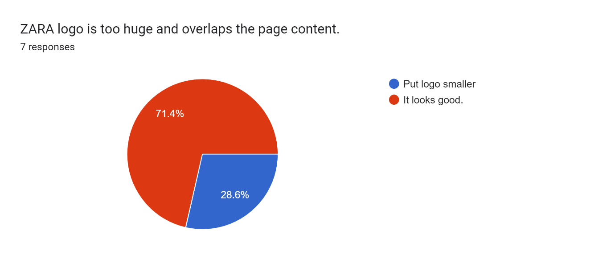

 

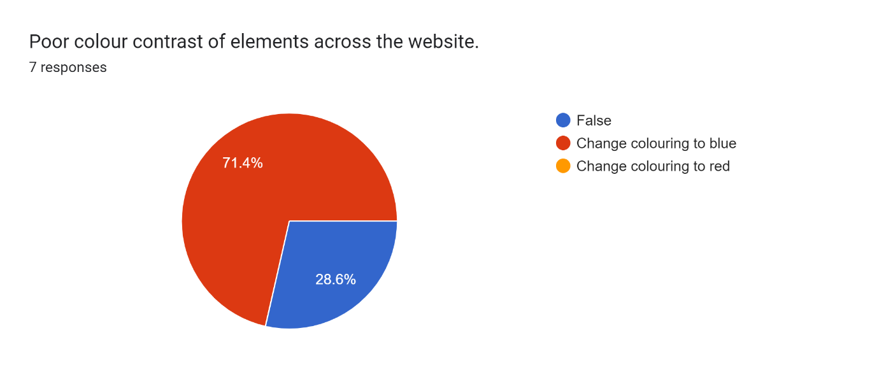 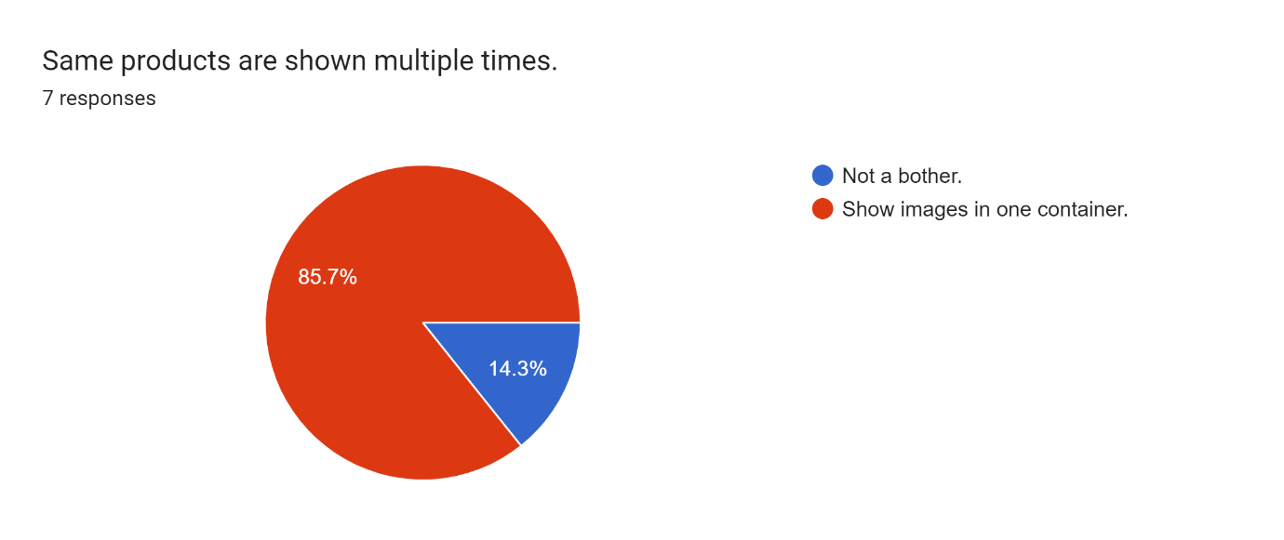

 

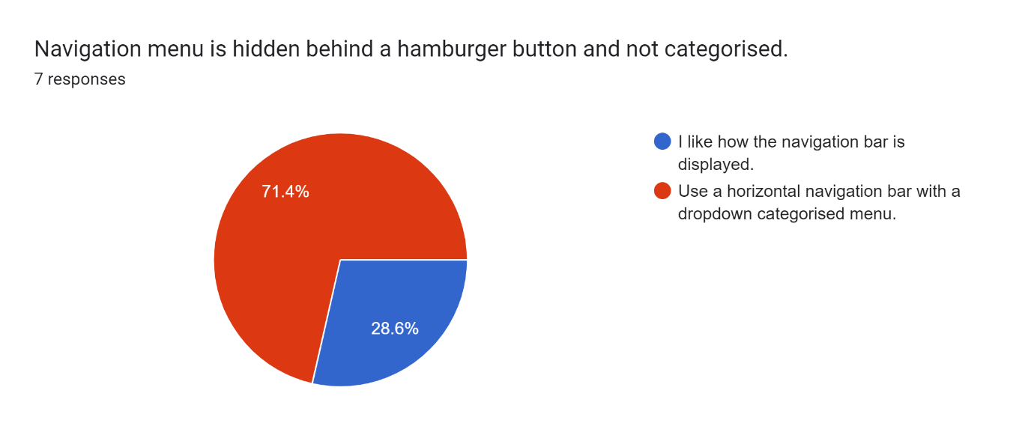

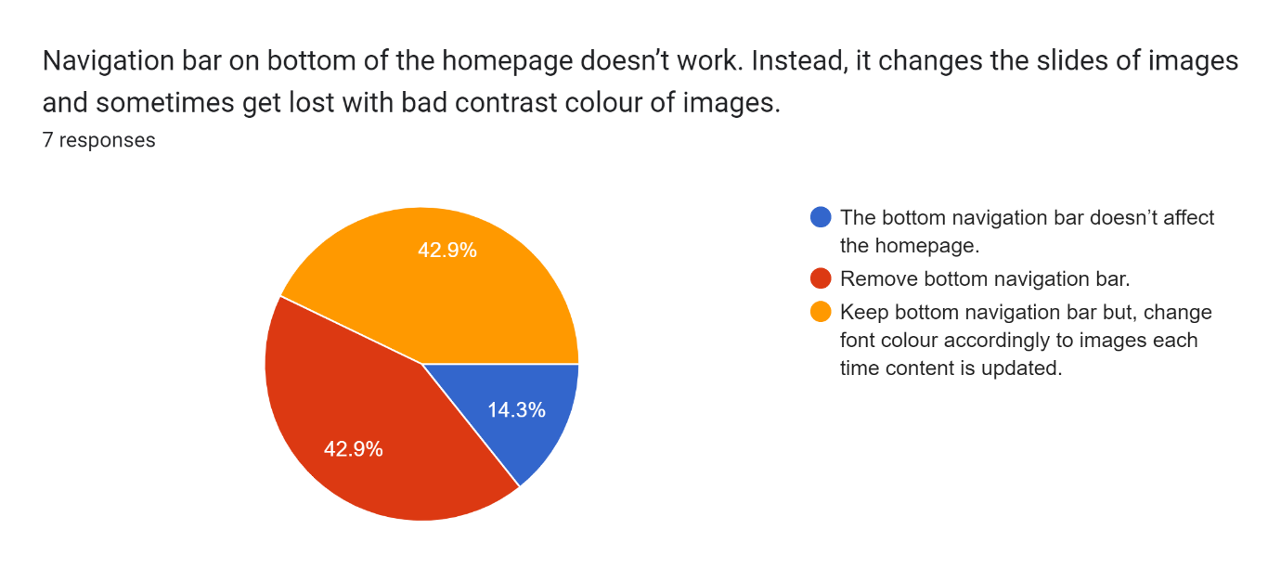

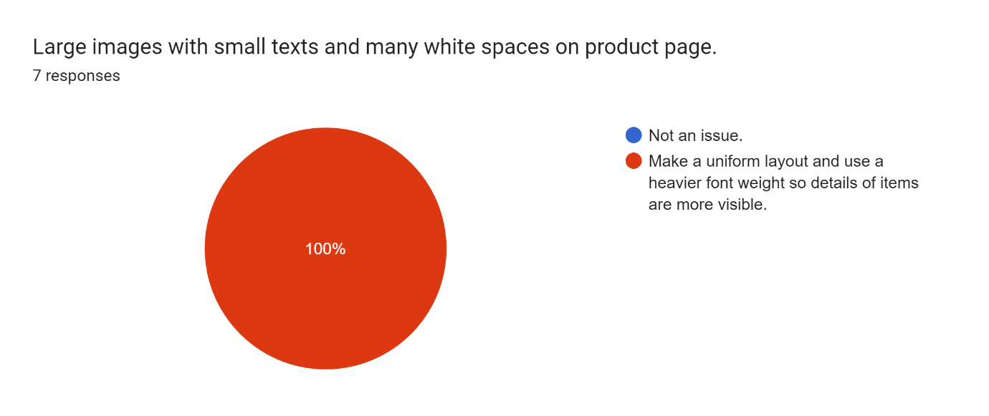

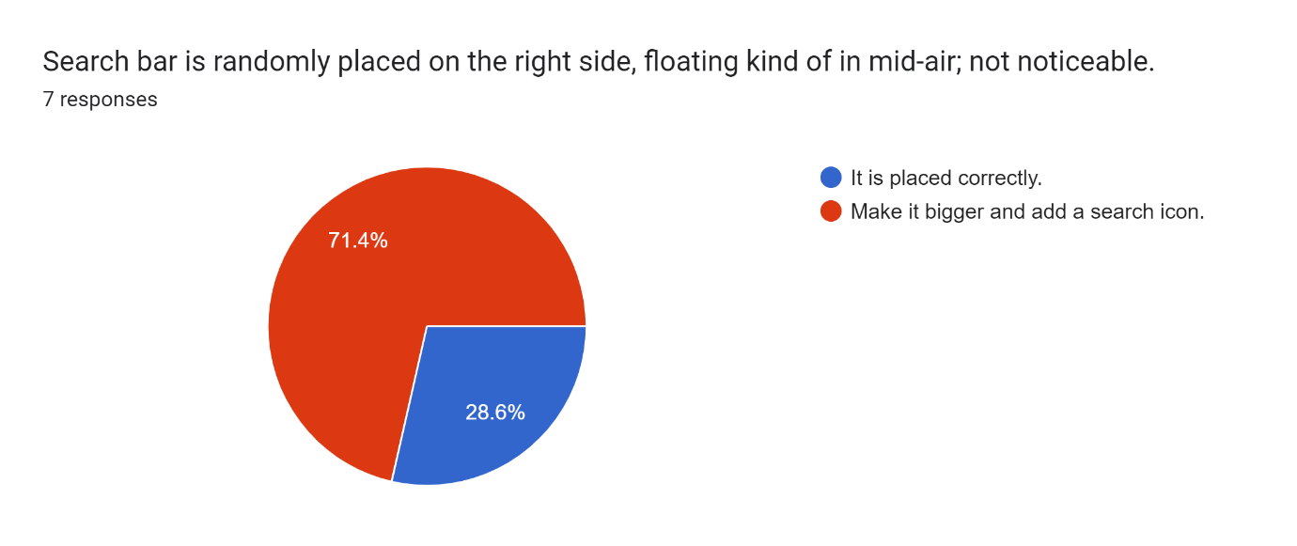

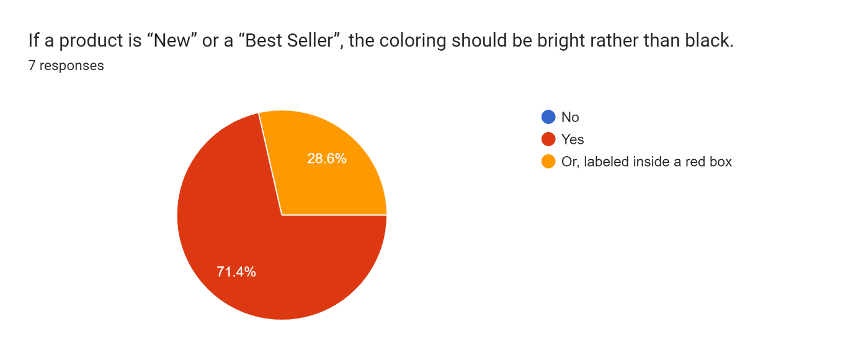

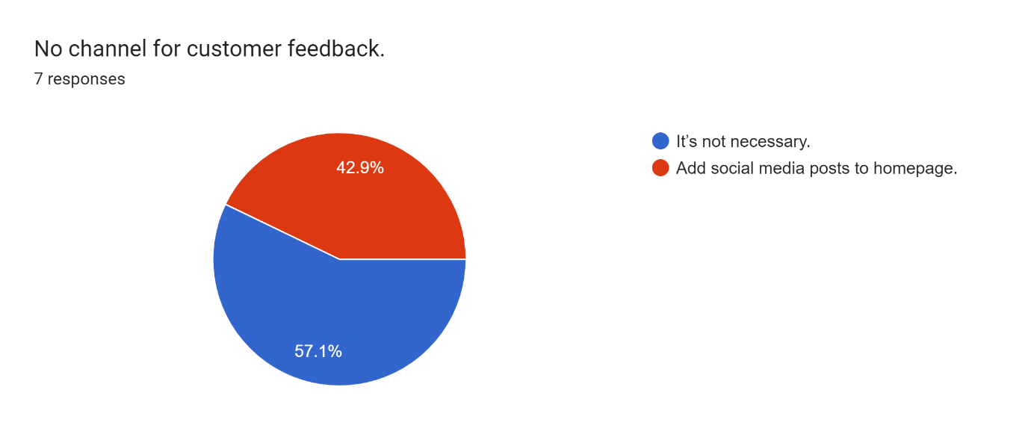 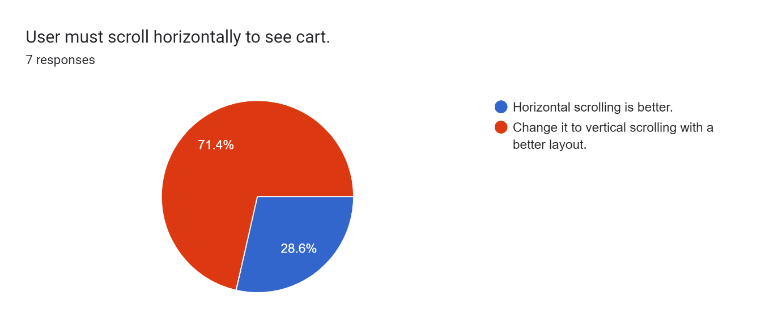

 

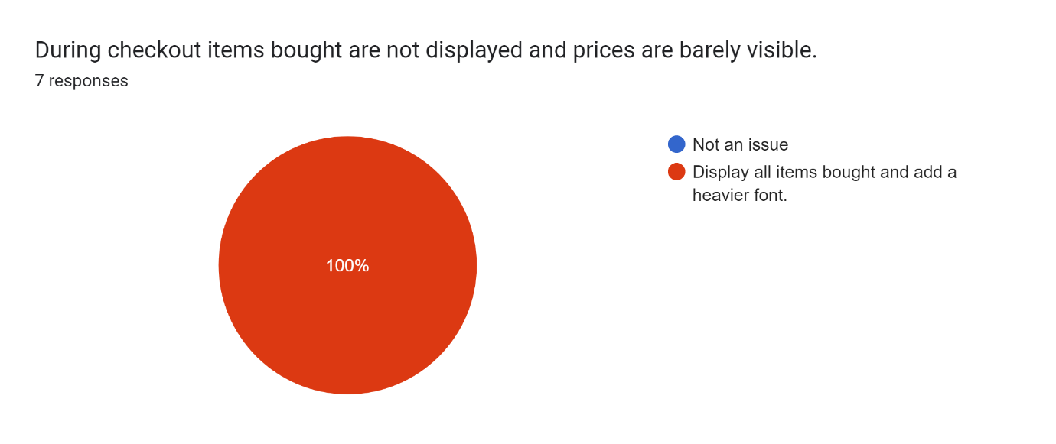

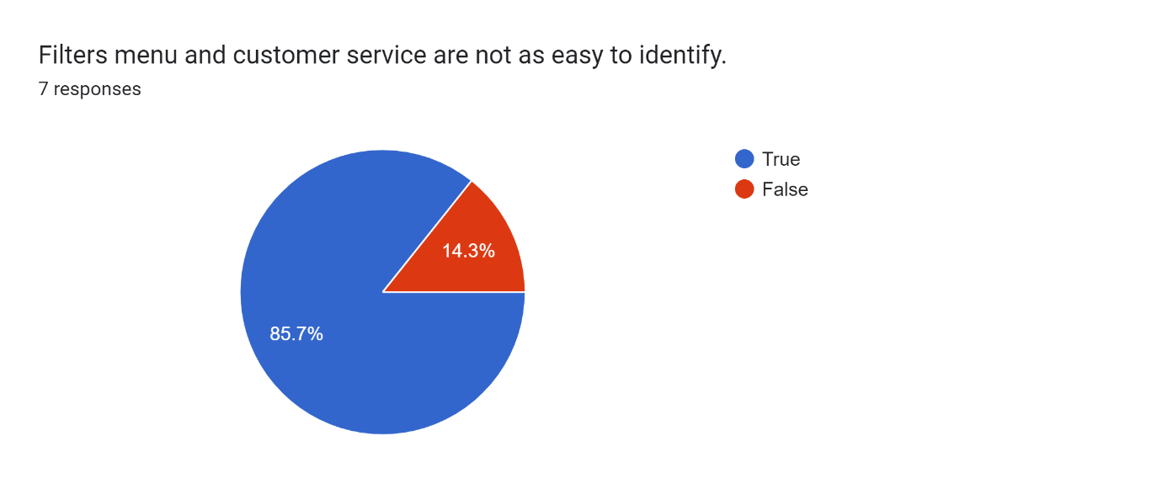

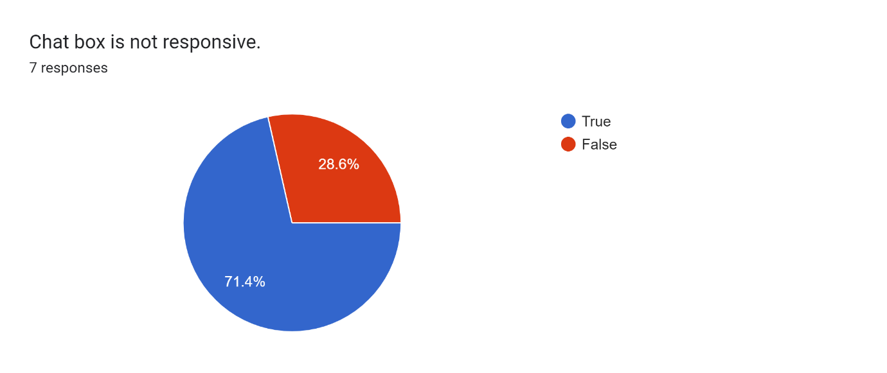 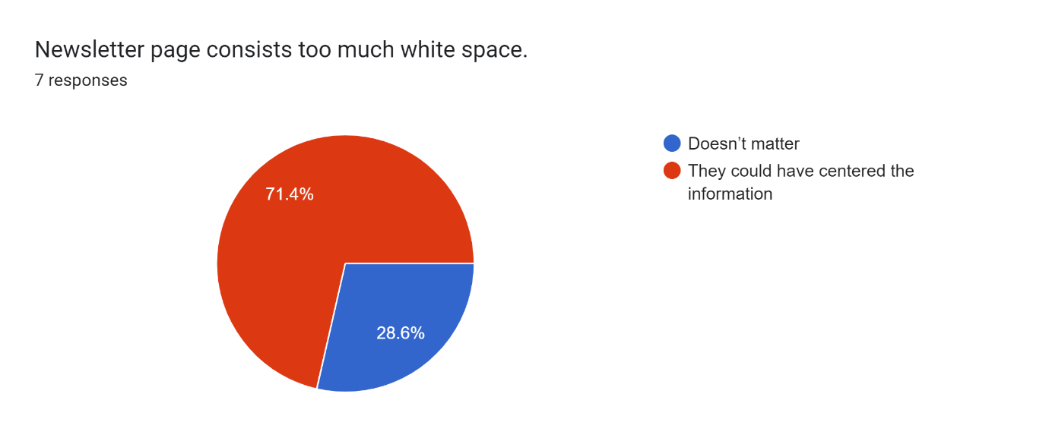

 

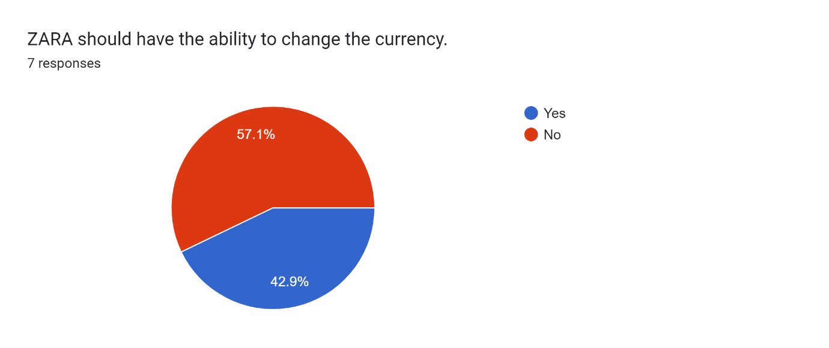

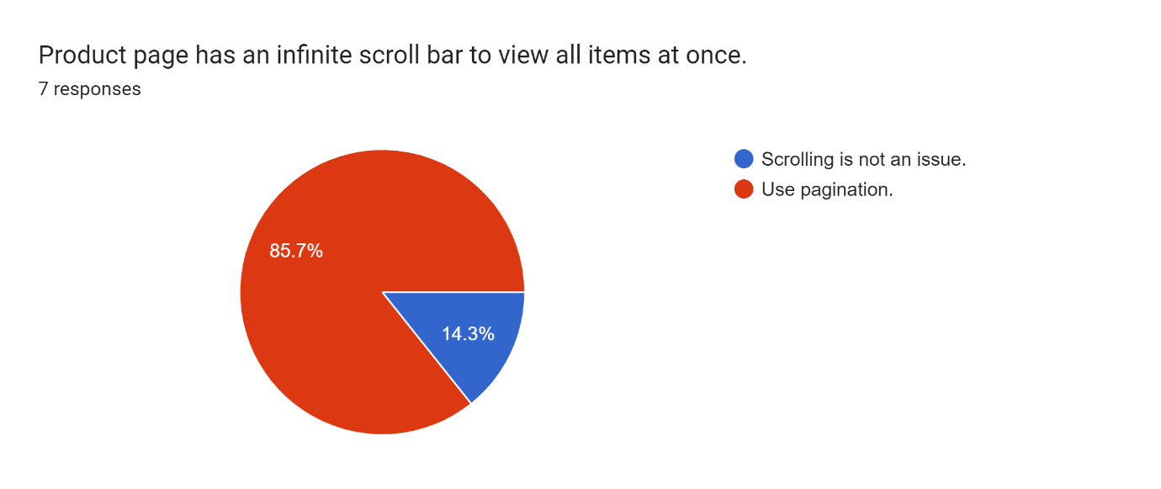

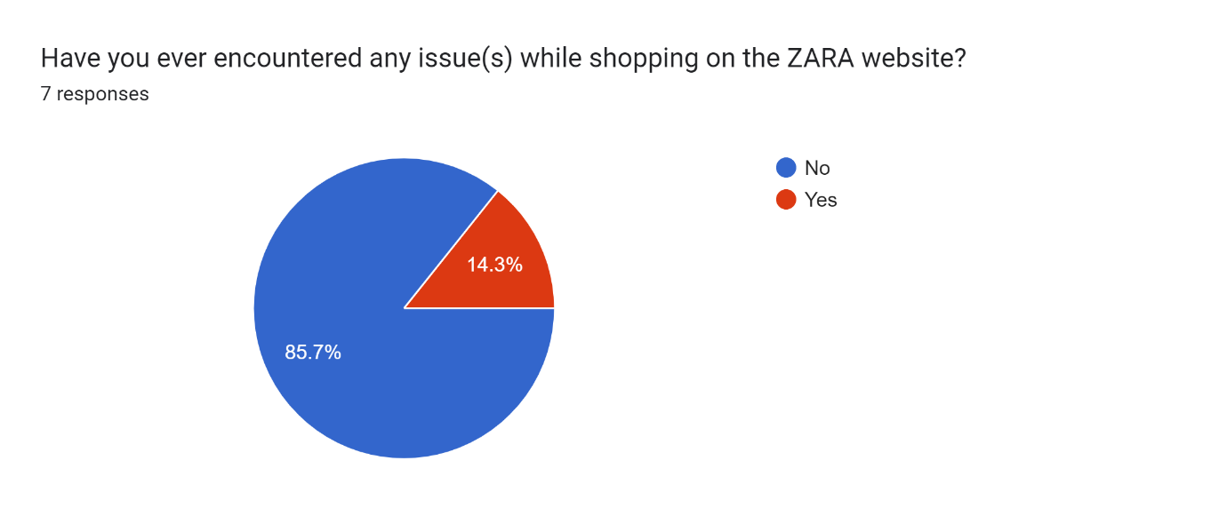  
If yes, please specify

The sizes are not there

# **Hypothesis**

The hypothesis contains different solutions that most of the participant that uses the ZARA website suggested. To make those changes going through the HCI principles is very crucial to be able to provide the users with an interface which they desire. The following changes are as follows; users want to be able to find product easier. Customers get a lot of issues while reading contents on the page such as description, price and more. They prefer a font size where information is visible and readable. Also, to make use of a darker font colors so users can view things clear without torturing their eyes and navigate on the website without any issues.

However, the users are against on how the navigation bar is displayed, which is hidden behind hamburger menu and very unorganized. They would rather want a horizontal navigation bar with a categorized dropdown menu. This will make the website more organized and will be easy for users to search an item faster within a click. Most of the customer do not like the color of the current website and mention to change it to blue. Having the website in blue color it makes the website more professional and ensure comfort and safety. Moreover, the users said having a uniform layout for the product page would be much better for them, so their time is not wasted by watching one or two item at a time rather view more items in no time. The majority of the users want that the website changes the horizontal scrolling to vertical scrolling mostly on the cart because they cannot see their recent item they added to cart. They must scroll at the end to find it.

According to human habits almost every users agree that the filter menu and customer service are not easy to identify. To improve that part, the designer should add these features where they are visible to user. Additionally, the chat box is not always responsive so to improve this feature there should always be someone 24/7 who will attend customers who are having trouble in navigating the site. Finally, it can be seen that many pages have too much of white space and according to the participants it is very overwhelming, so instead of wasting those white spaces, there could have used it in a more efficient way by making the page more informative, professional, and appealing to the users.

# **Conclusion**

To wrap everything up, the ZARA website has indeed some really good features that makes it stand out from other e-commerce website especially because of its accessibility control feature. However, after analyzing the quantitative research and our heuristic evaluation based on its usability issues, it has shown that the website needs to fill in some missing bits to make it a user friendly and a more professional looking website. Referring to our solutions proposed in the hypothesis, these new implementations will make the website have a much better interface and most importantly an overall good experience for the online shoppers!

**References**

<https://medium.com/@domsye/zara-an-e-commerce-ux-ui-case-study-8e3109cb1a7f>

<https://en.wikipedia.org/wiki/Zara_(retailer)#:~:text=In%20September%202010%2C%20Zara%20launched,the%20Netherlands%2C%20Belgium%20and%20Luxembourg>.

<https://martinroll.com/resources/articles/strategy/the-secret-of-zaras-success-a-culture-of-customer-co-creation/>

<https://medium.com/@meijie92/design-evaluation-of-three-popular-fashion-websites-h-m-levis-zara-36b0e6fe81f1#:~:text=Functionality%3A%20Zara's%20website%20allows%20users,Links%20work%20and%20everything%20responds>.

<https://shivaninallainathan.com/zara>